# Introduction

## OS – User View

* all about how the user has to interact with the operating system with the help of various application programs

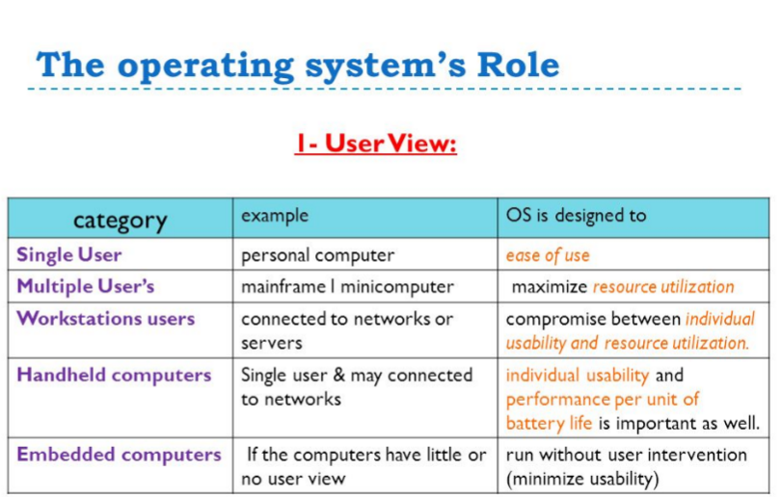

## OS – System View

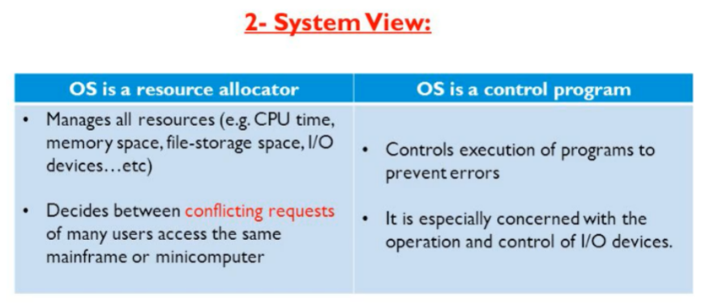

* OS is one program running at all times
  + Kernel

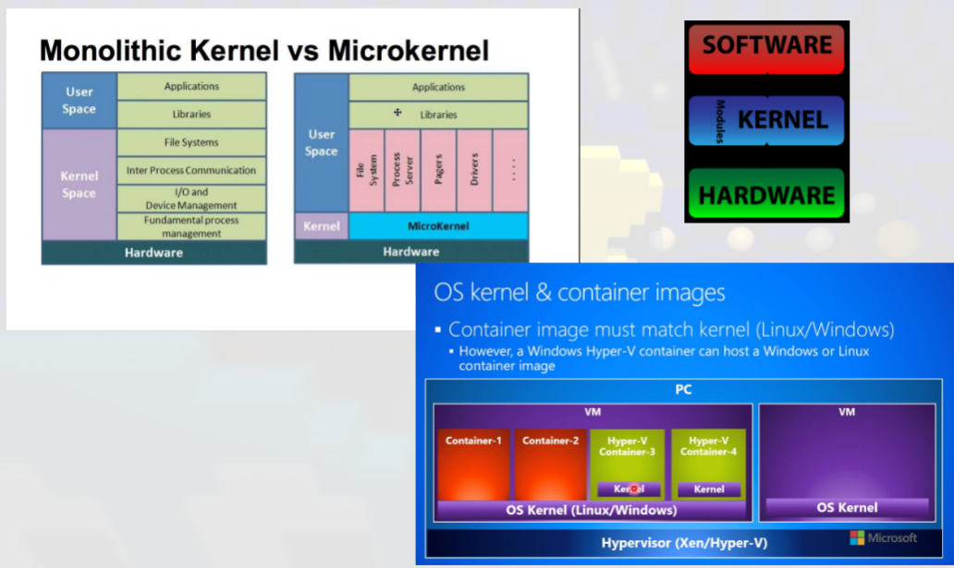

## Boot Process

* Six steps of the booting process are BIOS and Setup Program, The Power- On-Self-Test (POST), The Operating system Loads, System Configuration, System Utility Loads and Users Authentication.

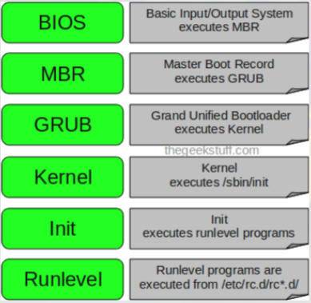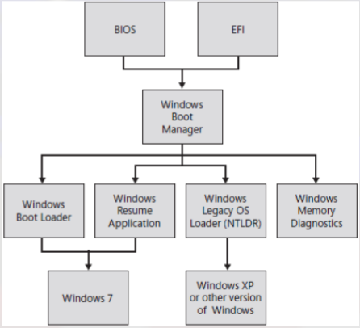

## Program interrupts – system calls

* A system call is a call by software running on the OS to services provided by the OS. An interrupt is usually external hardware component notifying the CPU/Microprocessor about an event that needs handling in software (usually a driver)

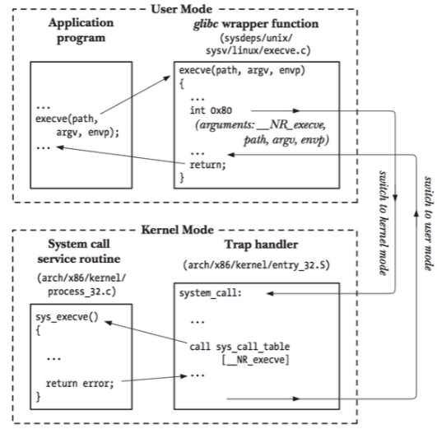

* An ‘Event’ – signaled by an interrupt – hardware or software

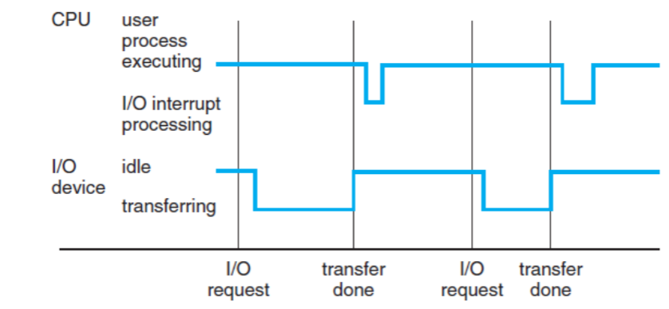

* CPU can load instructions – only from memory.
  + RAM / DRAM
  + ROM / EEPROM
* Typical instruction – execution cycle – von Neumann architecture:

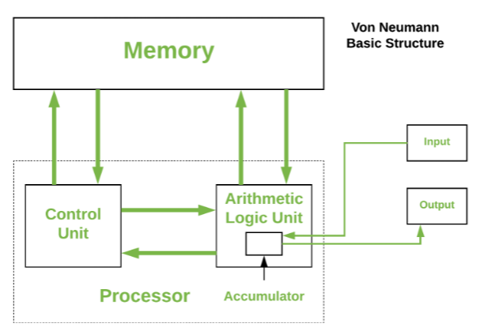

## Storage

* DVD, SSD, cloud, USB, Hard Disk, NAS, Multimedia drive

## Computer System Architecture

* Organized in a number of different ways
* Single-Processor system
* Multi-Processor systems (parallel or multi-core)
  + Asymmetric multiprocessing (Boss)
  + Symmetric multiprocessing (no Boss)
* OS Structure

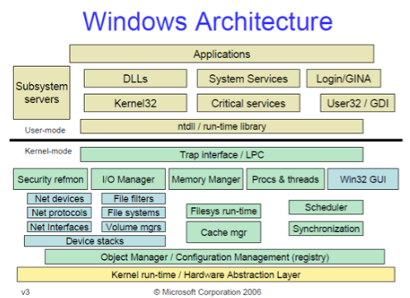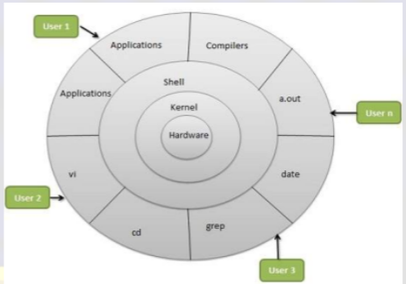

## OS Operations

* Interrupt driven by hardware
* Software error or request creates exception or trap
  + Division by zero, request for operating system service
* Other process problems include Infinite loop, processes modifying each other or the operating system
* Dual-mode operation allows OS to protect itself and other system components
  + User mode and kernel mode
  + Mode bit provided by hardware
    - Provides ability to distinguish when system is running user code or kernel code
    - Some instructions designated as privileged, only executable in kernel mode
    - System call changes mode to kernel, return from call resets it to user
* Timer – ensure OS maintains control over the CPU